**Department of Electrical Engineering and   
Computer Science**

**Faculty Member:** Ma’am Neelma Naz **Dated:** 21/09/2022

**Semester:** 6th **Section:** BEE 12C

**LAB 9: Root Locus based Design**

**Lab Instructor: Sir. Yasir Rizwan**

|  |  |  |  |  |
| --- | --- | --- | --- | --- |
| Student Name | Reg. No. | Lab Report Marks / 10 | Viva Marks  / 5 | Total  /15 |
| **Muhammad Ahmed Mohsin** | **333060** |  |  |  |
| **Imran Haider** | **332569** |  |  |  |
| **Zafar Azhar** | **3325689** |  |  |  |

Table of Contents

LabVIEW 3

Introduction 3

Software Used 3

Objectives 3

Introduction to LabVIEW 4

3. Virtual Instruments (VIs) 4

4. Palettes 7

5. Wires 9

Lab Exercises: 10

Inputs 10

Outputs 10

Requirements 10

OUTPUTS: 11

Output 1: 11

Output :2 11

Output: 3 12

Exercise: 2 12

Outputs: 12

Output:1 13

Output:2 13

Output:3 14

Conclusion: 14

**Root Locus based Design.**

# Introduction

• Learn how to plot root locus in MATLAB

• Learn how to use MATLAB to design a simple controller using the root locus

# Root Locus

Root locus is a plot of the closed loop poles of the system that shown in the figure below. The closed loop poles vary as the values of the gain K is changed. The root locus shows the plot of the closed loop poles as the gain K is varied between zero and positive infinity.

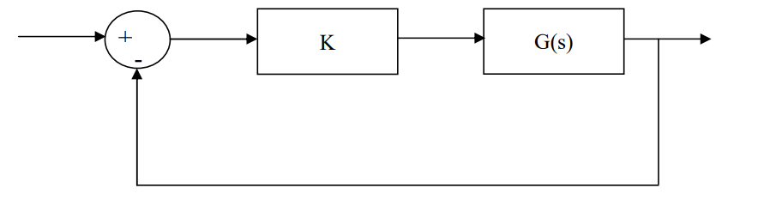

# Root Locus in MATLAB

In MATLAB, the root locus can be plotted with the command rlocus(). Consider the open loop system.

The root locus of the above system can be plotted in MATLAB using the following code: G=zpk([],[-1,-2,-3],1)

rlocus(G)

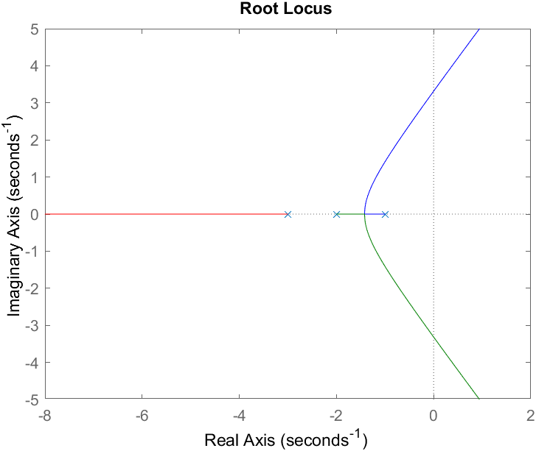

As an exercise move the data cursor, to find

1. The gain at which you have imaginary axis crossing
2. ii. The value of the pole and the gain at the breakaway point

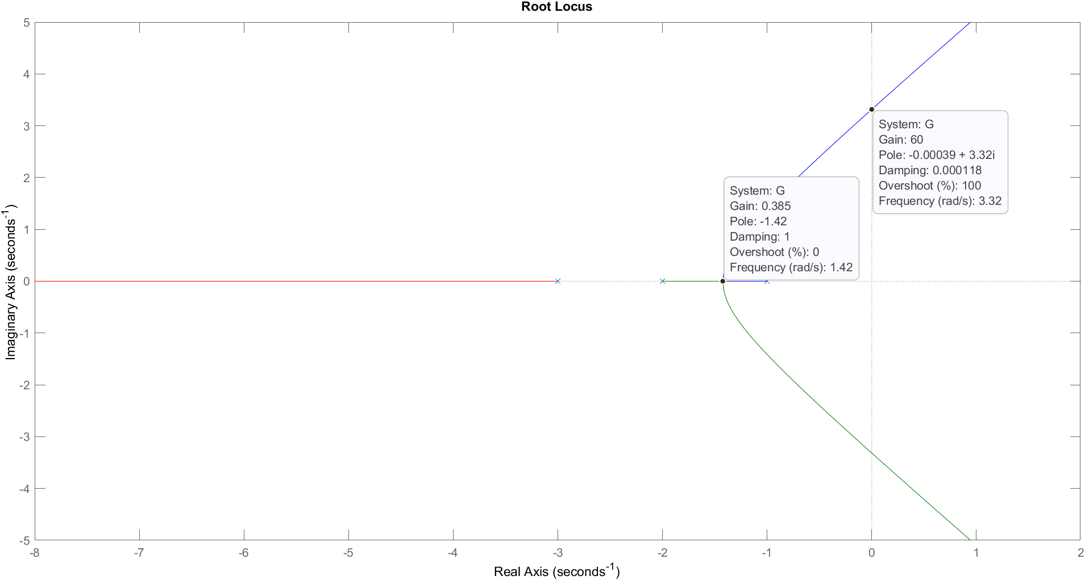

Move the data cursor for one of the complex poles so that you have an overshoot of 40%. Find the value of K required to get that closed loop pole.

The value of gain is 18.

K=18;

Gcl = feedback(series(K,G),1)

Gcl =

18

--------------------------------

(s+4.748) (s^2 + 1.252s + 5.055)

Continuous-time zero/pole/gain model.

Move the rest of the data cursors such that they are showing the same value of the gain K. This will allow us to see the location of all the closed loop poles of the system for a specific value of the gain.

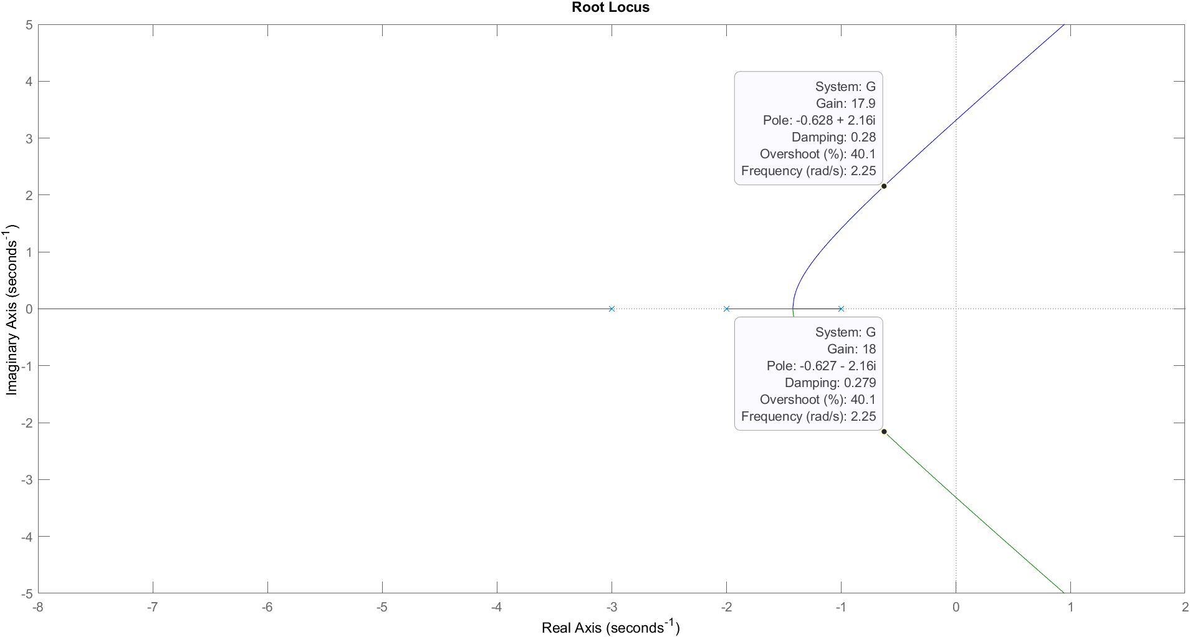

For the value of gain that is required for 40% overshoot, can we approximate the systems to a second order system with no zeros?

Once you have decided a value for the gain K, you can find the closed loop transfer function with the following code

K=18

Gcl = feedback(series(K,G),1)

Gcl =

18

--------------------------------

(s+4.748) (s^2 + 1.252s + 5.055)

Continuous-time zero/pole/gain model.

# Exercise: 1

Consider the open loop system

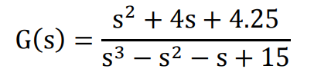

Plot the root locus for this system in MATLAB. Using the MATLAB root locus:

1. Find the values of the gain K for which the closed loop system will be stable.

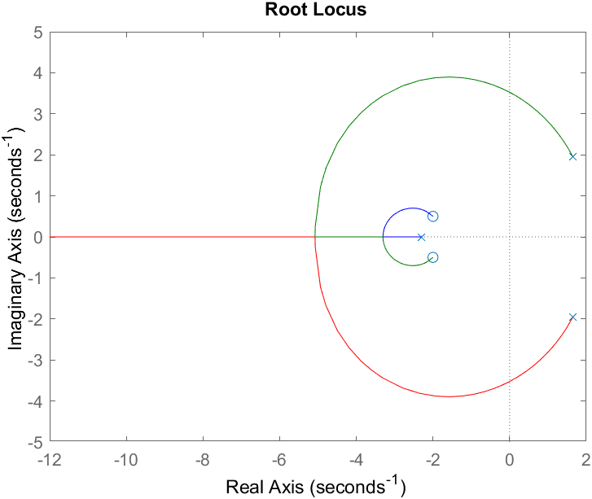

After making the system stable, we have for the gain value of K=3.35. The system now becomes stable.

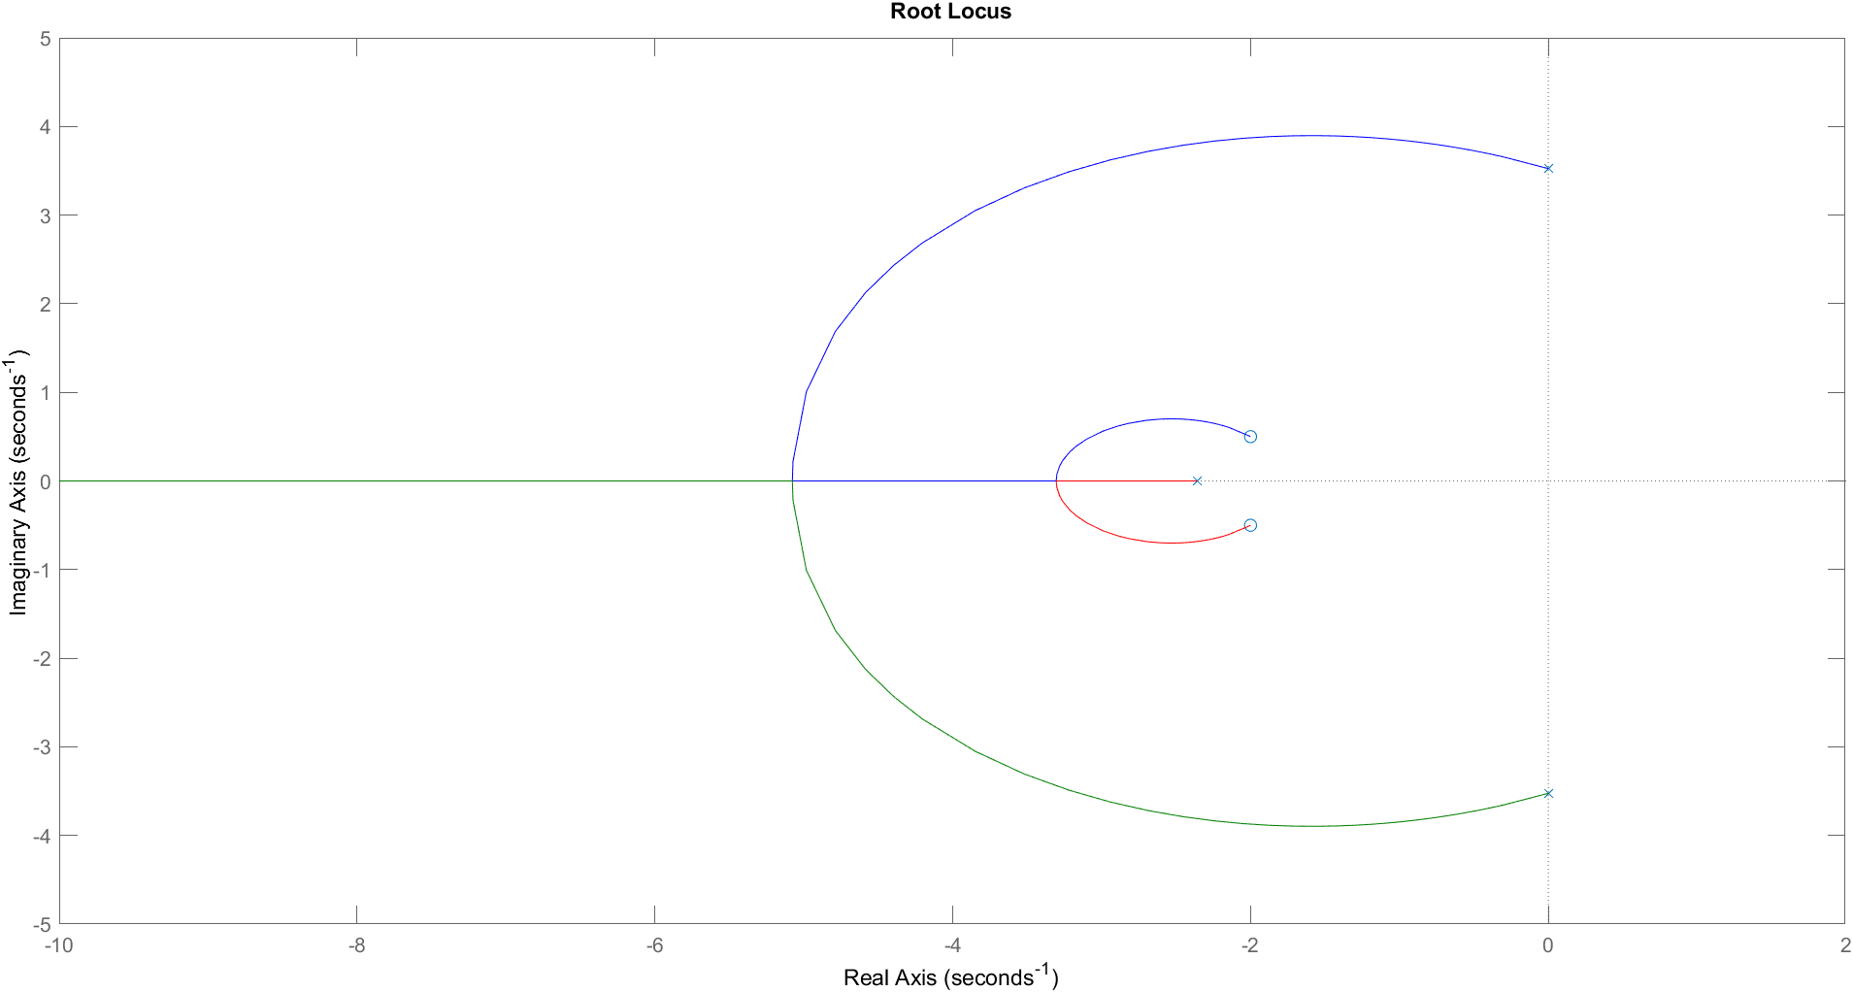

%% Excercise 1

num=[1 4 4.25];

dem=[1 -1 -1 15];

H=tf(num,dem);

rlocus(H);

K2=3.35;

Gcl = feedback(series(K2,H),1);

rlocus(Gcl);

1. Design a controller gain K such that the closed system is stable and the dominant poles have an overshoot of 80%. Is a second order approximation valid for this value of K. Find the transfer function of the closed loop system.

We find the vale of k to be 3.884 and thus the system becomes stable with 80 percent overshoot at the ends as shown.

num=[1 4 4.25];

dem=[1 -1 -1 15];

H=tf(num,dem);

rlocus(H);

K2=3.884;

Gcl = feedback(series(K2,H),1);

rlocus(Gcl);

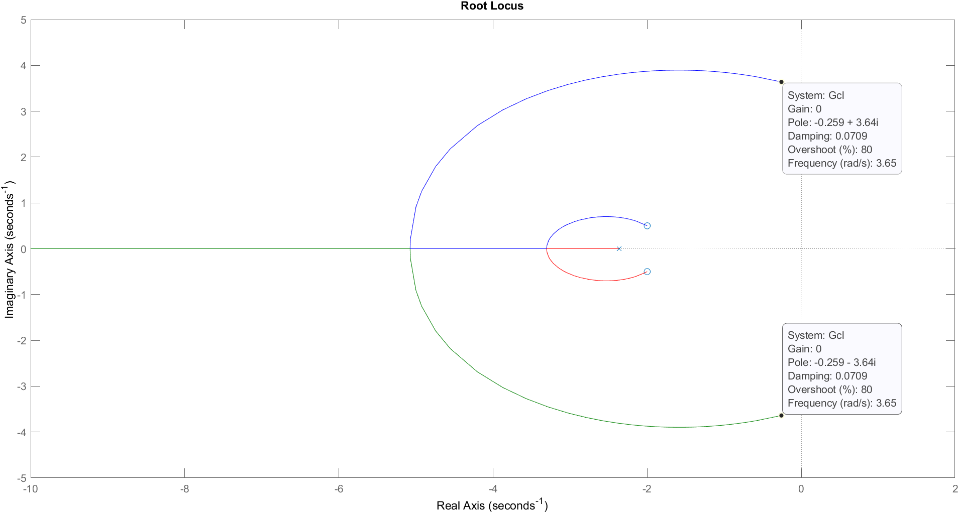

# Exercise 2

Consider the first order model of the DC motor speed vs voltage, which you have derived in your earlier labs. You get a first order model if you neglect the inductance, i.e. L=0. Using the root locus, choose a value of K such that your settling time is 1/20 secs. Find the transfer function of the closed loop system.

The root locus for the first order systems is given as:

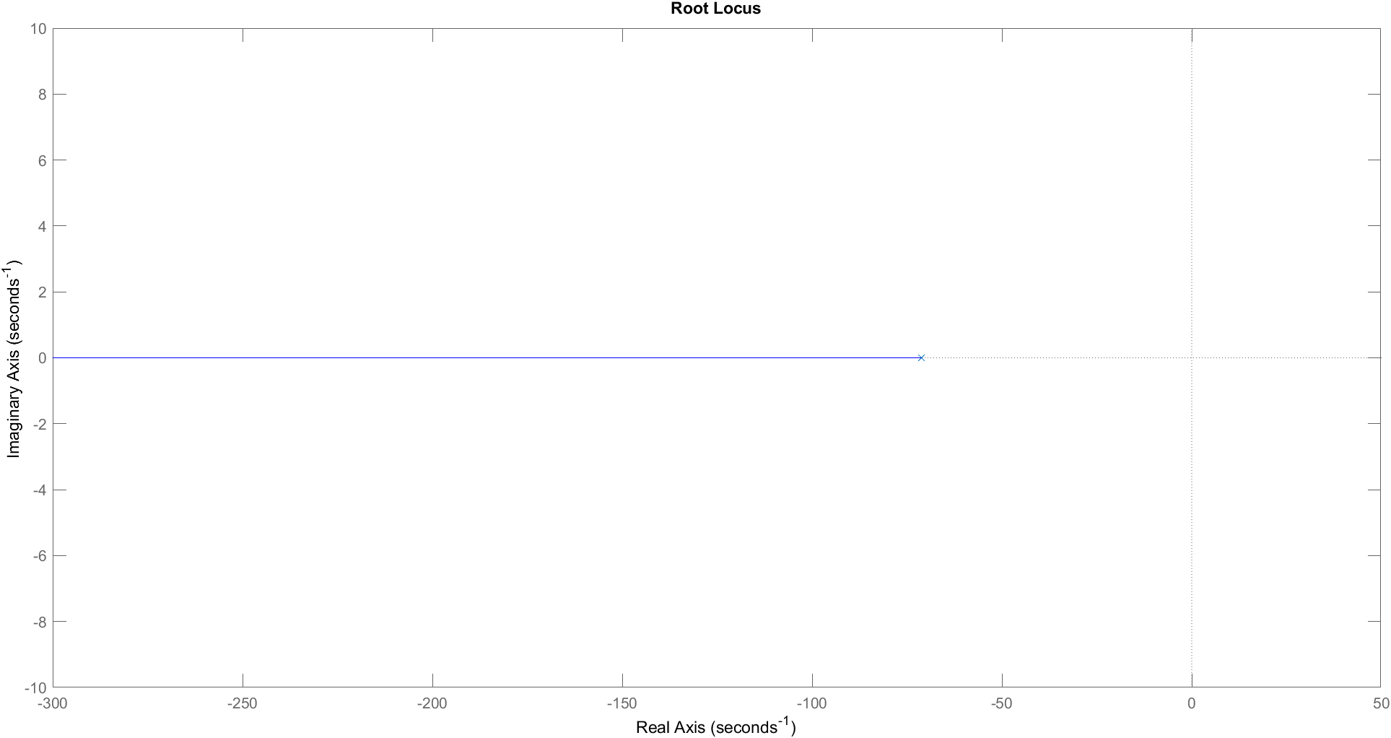

By using the information of the response using stepinfo we iterate different values of K to get a settling time of 1/20s.

num= 0.0334;

den=[1.566e-5 ,1.11556e-3];

H2=tf(num,den);

rlocus(H2);

stepinfo(H2);

K3=0.0040;

Gcl=feedback(series(K3,H2),1);

stepinfo(Gcl)

Answer:

RiseTime: 0.0275

TransientTime: 0.0490

SettlingTime: 0.0490

SettlingMin: 0.0963

SettlingMax: 0.1069

Overshoot: 0

Undershoot: 0

Peak: 0.1069

PeakTime: 0.1322

## Transfer function:

Gcl =

0.0001336

----------------------

1.566e-05 s + 0.001249

Continuous-time transfer function.

# Exercise 3

Consider the first order model of the DC motor position vs voltage that you have derived in your earlier labs. Using the root locus, choose a value of K such that your closed loop system is stable and has a settling time of 1/5 secs. Find the transfer function of the closed loop system.

We use stepinfo command to iterate through different values of k to make the settling time equal to 1/5s.

num= 0.0334;

den=[1.566e-5 ,1.11556e-3,0];

H3=tf(num,den);

rlocus(H3);

stepinfo(H3);

k4=.5;

Gcl=feedback(series(k4,H3),1);

stepinfo(Gcl)

The transfer function is:

Gcl =

0.0167

-----------------------------------

1.566e-05 s^2 + 0.001116 s + 0.0167

The rise time is given as:

RiseTime: 0.1168

TransientTime: 0.2090

SettlingTime: 0.2090

SettlingMin: 0.9032

SettlingMax: 1.0000

Overshoot: 0

Undershoot: 0

Peak: 1.0000

PeakTime: 0.4971

The root locus is given as:

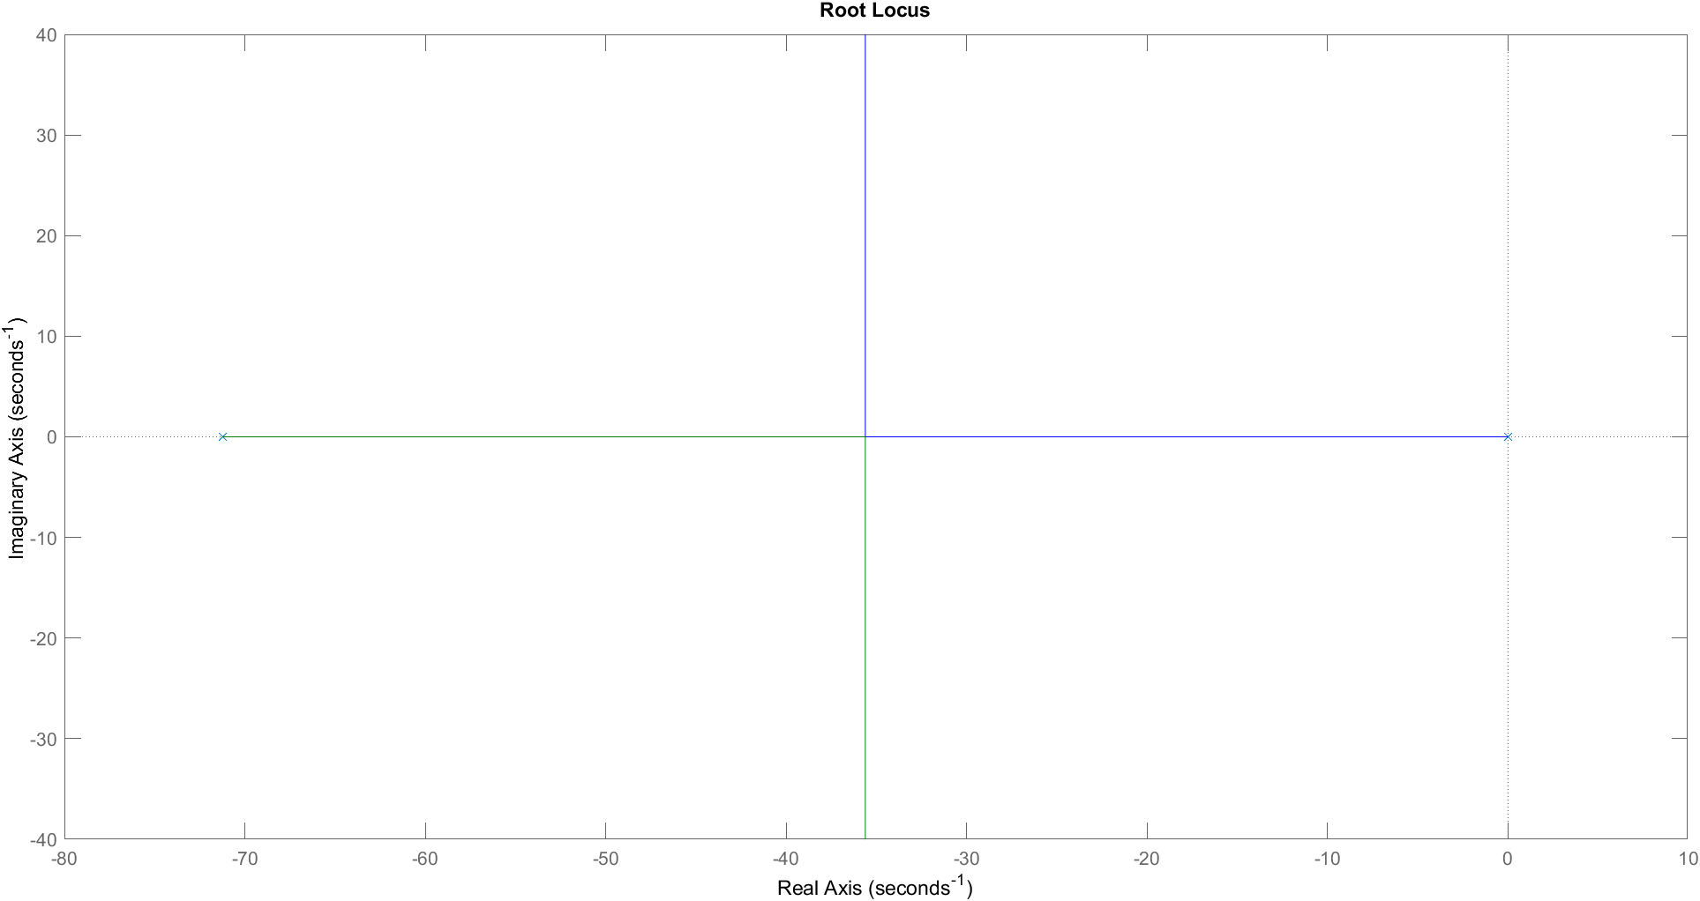

# Exercise: 4

Without using MATLAB, make a rough sketch of the root locus of the following transfer functions:

## Transfer Fucntion:1

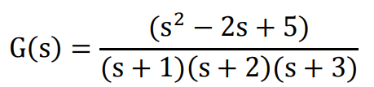

## Transfer Function:2

## transfer function 3:

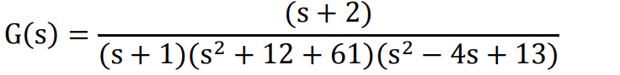

# Hand drawn

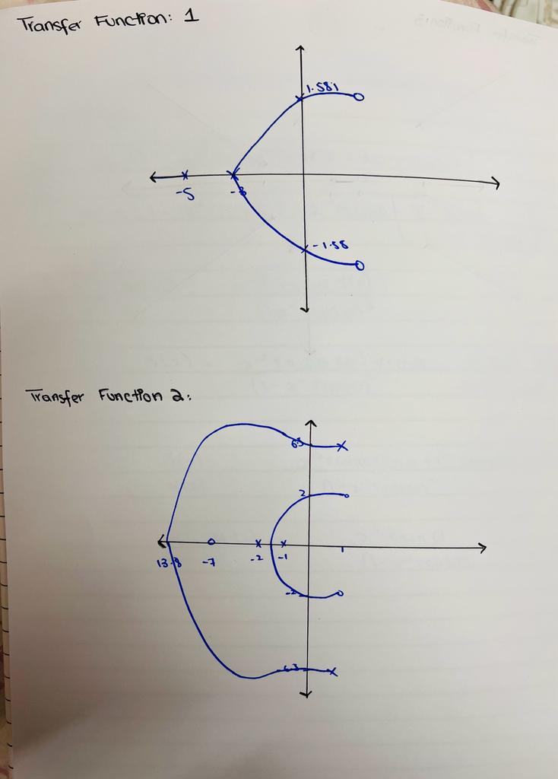

# Conclusion

In conclusion, this lab report aimed to investigate and analyze the root locus of different transfer functions using MATLAB. Through the use of various MATLAB commands and functions, the root locus of different transfer functions was plotted and analyzed. The root locus is a powerful tool that helps in the analysis and design of control systems. It provides useful information about the stability and performance of the system.

In this lab report, we have successfully plotted the root locus of different transfer functions and studied their characteristics. We observed that the root locus can be used to predict the behavior of the system and make design decisions that improve its performance. Furthermore, we saw how changes in the system parameters affect the root locus and, consequently, the behavior of the system.

Overall, this lab report has given us a better understanding of linear control systems and the use of the root locus in their analysis and design. The experience gained from this lab report will be beneficial in future engineering projects where control systems are involved.